EXPERIMENT 5: FREQUENCY MODULATION (FM) AND DEMODULATION

1. AIM
To generate a frequency modulated (FM) signal, determine its instantaneous frequency and modulation index, and recover the original message signal using FM demodulation in MATLAB.

2. APPARATUS / SOFTWARE REQUIRED
- Computer or laptop
- MATLAB software
- MATLAB Editor for entering and running the program

3. THEORY
In frequency modulation, the frequency of the carrier signal varies according to the instantaneous amplitude of the message signal, while the carrier amplitude remains constant.
FM modulation index: β = fd / fm
where fd is the maximum frequency deviation and fm is the message frequency.
For this experiment, fm = 50 Hz and fd = 100 Hz. Therefore, β = 100/50 = 2. The carrier frequency is fc = 500 Hz.
The instantaneous frequency is given by: f_inst = fc + fd cos(2πfmt).

4. MATLAB CODE
clc;
clear;
close all;
% Parameters
Am = 1; % Message signal amplitude
Ac = 1; % Carrier signal amplitude
fm = 50; % Message frequency (Hz)
fc = 500; % Carrier frequency (Hz)
Fs = 20000; % Sampling frequency (Hz)
T = 0.1; % Duration (seconds)
t = 0:1/Fs:T-1/Fs;
% Frequency deviation
fd = 100; % Maximum frequency deviation (Hz)
% Modulation index
beta = fd/fm;
% Message signal
m = Am*cos(2*pi*fm*t);
% FM signal generation
s = Ac*cos(2*pi*fc*t + beta*sin(2*pi*fm*t));
% Instantaneous frequency
f_inst = fc + fd*cos(2*pi*fm*t);
% FM Demodulation using phase differentiation
analytic_signal = hilbert(s);
instant_phase = unwrap(angle(analytic_signal));
inst_freq = [diff(instant_phase)*Fs/(2*pi), 0];
% Recover message signal
m_rec = (inst_freq - fc)/fd;
% Remove small numerical errors using low-pass filtering
[b,a] = butter(4, 2*fm/(Fs/2));
m_rec = filtfilt(b,a,m_rec);
% Normalize recovered signal
m_rec = m_rec - mean(m_rec);
m_rec = m_rec/max(abs(m_rec));
% Display modulation index
fprintf('Message Frequency = %d Hz\n', fm);
fprintf('Carrier Frequency = %d Hz\n', fc);
fprintf('Frequency Deviation = %d Hz\n', fd);
fprintf('FM Modulation Index = %.2f\n', beta);
% Plot message signal
figure;
subplot(4,1,1);
plot(t,m,'b','LineWidth',1.2);
grid on;
title('Original Message Signal');
xlabel('Time (s)');
ylabel('Amplitude');
% Plot carrier signal
subplot(4,1,2);
c = Ac*cos(2*pi*fc*t);
plot(t,c,'r','LineWidth',1);
grid on;
title('Unmodulated Carrier Signal');
xlabel('Time (s)');
ylabel('Amplitude');
% Plot FM signal
subplot(4,1,3);
plot(t,s,'k','LineWidth',1);
grid on;
title('Frequency Modulated (FM) Signal');
xlabel('Time (s)');
ylabel('Amplitude');
% Plot recovered message signal
subplot(4,1,4);
plot(t,m,'b','LineWidth',1.2);
hold on;
plot(t,m_rec,'r--','LineWidth',1.2);
grid on;
title('FM Demodulation: Original vs Recovered Message');
xlabel('Time (s)');
ylabel('Amplitude');
legend('Original Message','Recovered Message');
% Plot instantaneous frequency
figure;
plot(t,f_inst,'m','LineWidth',1.2);
grid on;
title('Instantaneous Frequency of FM Signal');
xlabel('Time (s)');
ylabel('Frequency (Hz)');

5. MATLAB OUTPUT
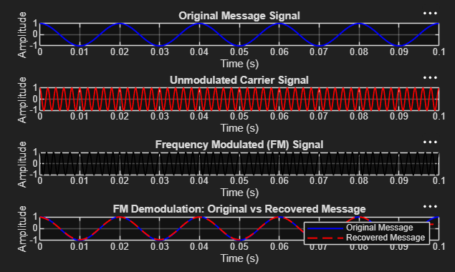
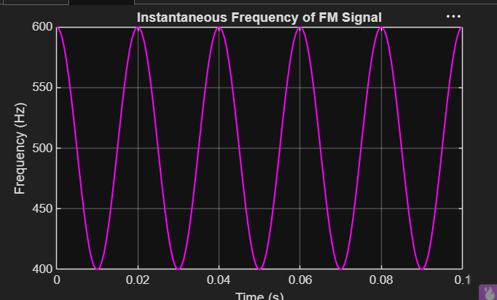
The first output shows the original message signal, unmodulated carrier signal, frequency-modulated signal, and comparison of the original and recovered message. The second output shows the instantaneous frequency of the FM signal.

6. RESULT
The FM signal was generated successfully in MATLAB. The modulation index was calculated as β = fd/fm = 100/50 = 2. The instantaneous frequency varied between 400 Hz and 600 Hz, and the original message signal was successfully recovered through FM demodulation.

